BALANCING FORM AND FUNCTION: Prescription Vs Description
- Prescription vs Description
- the thing that will make you the best visual designer you can be is knowing why you make the visual decisions you make, that’s the only thing that seperates you from everyone else
- 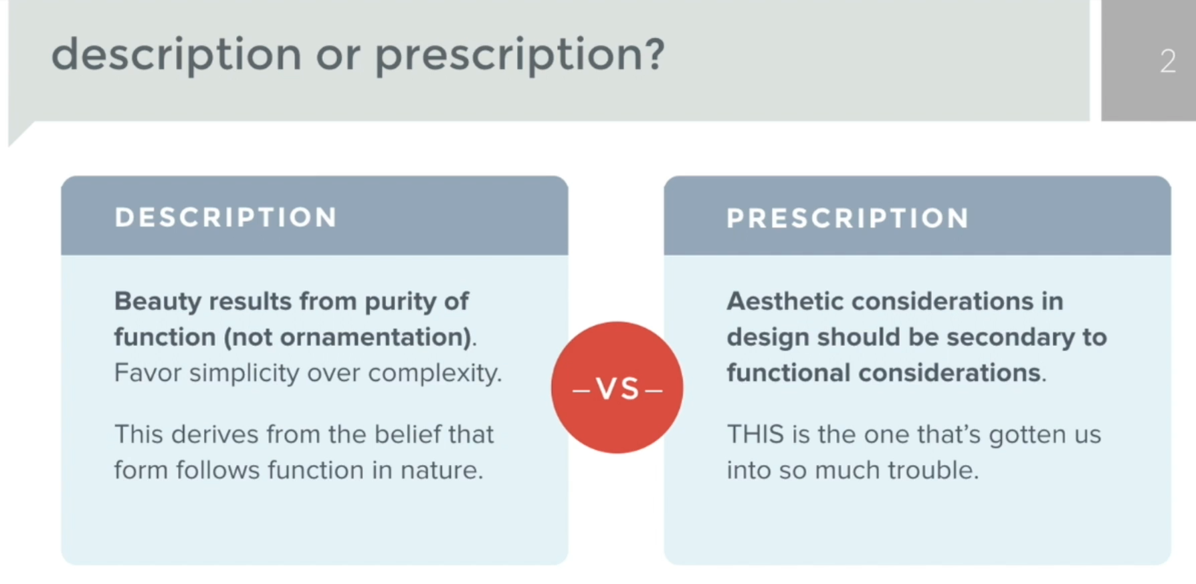
- form doesn’t follow function in nature, prescription is how engineers and programmers are thought and it’s wrong
- 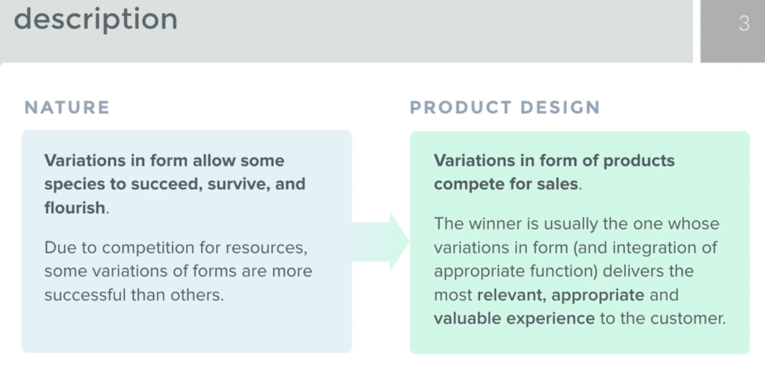
- 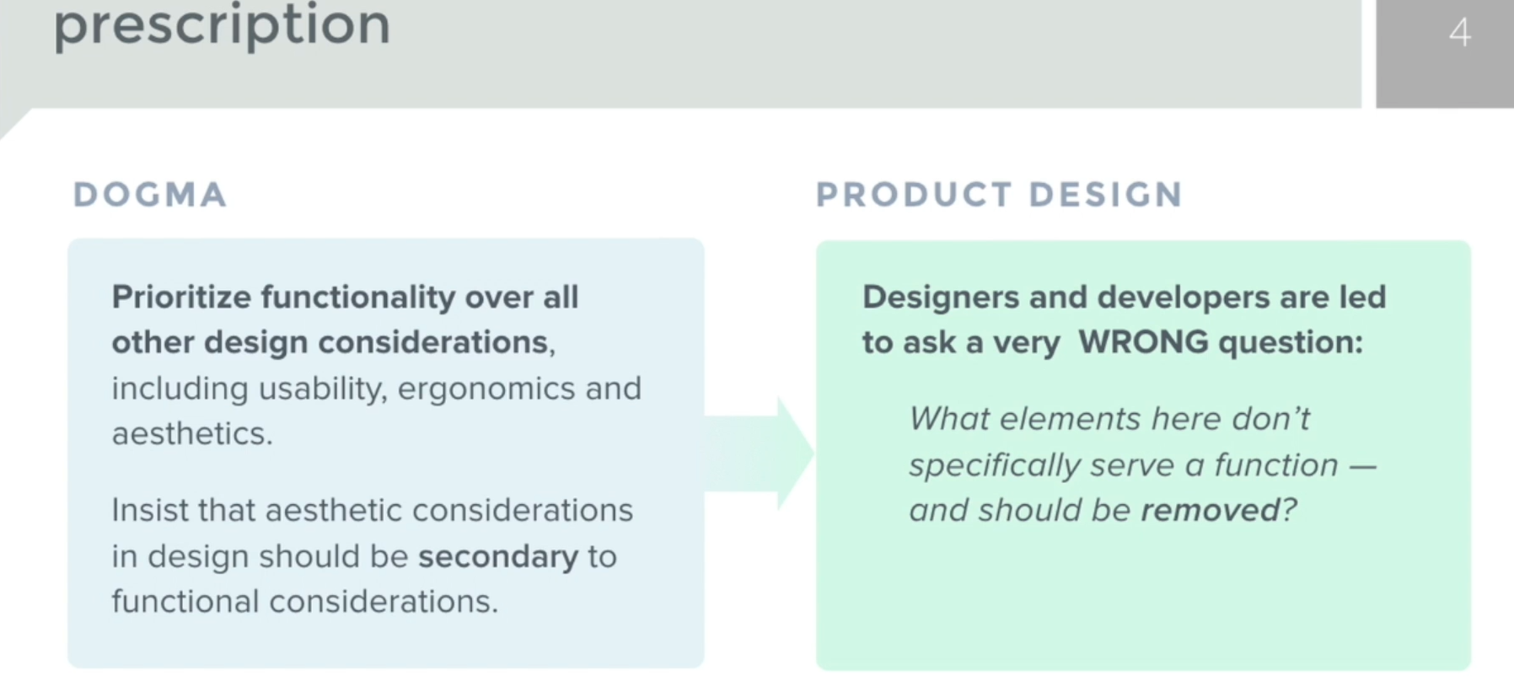
- prescriptions treat symptoms not problems, design is problem solving, and design is different from decoration
- 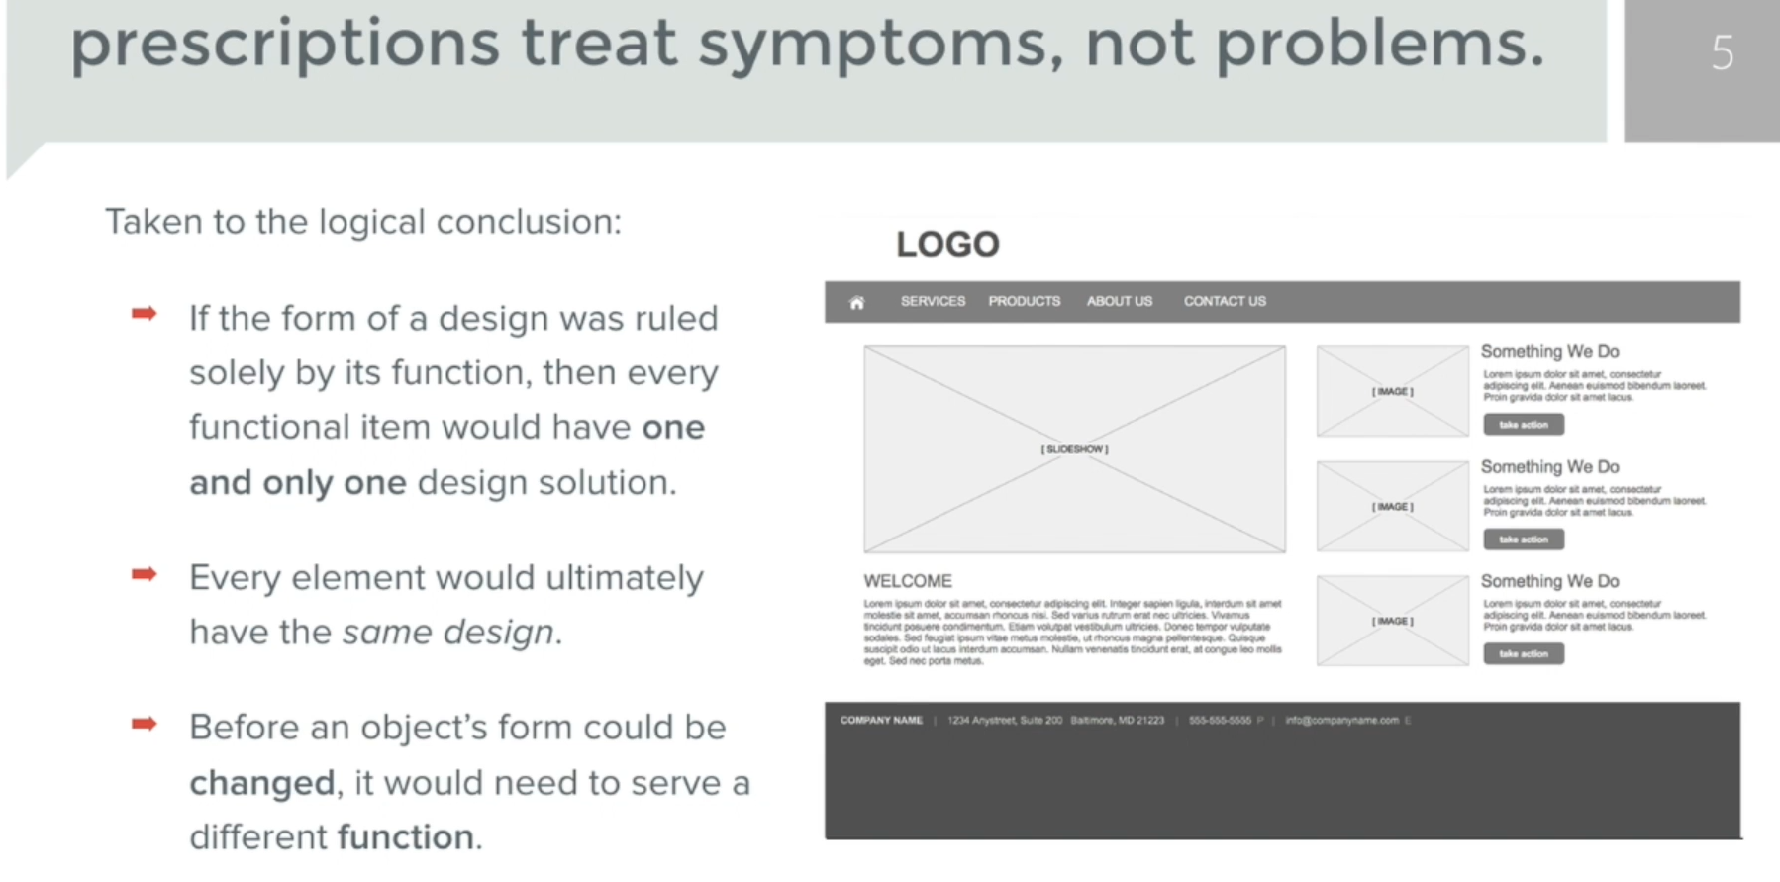
- according to his argument, if all clothes were clothes then there would be no children clothed, just clothes or if all web sites were websites there would be no need for hifi designs as all sites would look the same, just the contents and function would differ

